**Power BI Assignment 5**

1. Explain DAX.

Answer: DAX is a collection of functions, operators, and constants that can be used in a formula, or expression, to calculate and return one or more values. Stated more simply, DAX helps you create new information from data already in your model.

DAX, which stands for Data Analysis Expressions, is a formula language primarily used in Microsoft Power BI, Power Pivot, and Analysis Services Tabular models for data analysis and manipulation. DAX is designed to work with tabular data structures, such as tables and columns, and it enables users to create custom calculations, measures, and calculated columns within these tools. DAX is similar in some ways to Excel formulas, but it's specifically optimized for working with relational data models.

Here are some key concepts and features of DAX:

* **Formulas**: DAX formulas are used to create calculations based on the data in your tables. These calculations can involve aggregations, filtering, and various calculations similar to what you might perform in a spreadsheet program.
* **Functions**: DAX provides a wide range of functions that allow you to perform various operations on your data. These functions can be mathematical, statistical, text-related, time-related, and more.
* **Contextual Evaluation**: DAX calculations are evaluated within a specific context. This context can be influenced by filters, slicers, and the row and column context of the data model. Understanding and managing this context is crucial for accurate calculations.
* **Calculated Columns**: These are columns that you create in a table using DAX expressions. Calculated columns are calculated row by row and are stored in the data model, allowing you to create new data points based on existing data.
* **Measures**: Measures are similar to calculated columns, but they are used for creating aggregated values, like sums, averages, and counts. Measures are evaluated on the fly, depending on the context in which they're used, making them more flexible and efficient for reporting and analysis.
* **Filter Context and Row Context**: These two types of contexts are fundamental to DAX calculations. Filter context refers to the filters applied to the entire dataset, while row context refers to the individual rows being evaluated in a calculation. Properly understanding and managing these contexts is key to writing accurate DAX formulas.
* **Time Intelligence**: DAX has built-in functions and features for handling time-based calculations, such as year-to-date, moving averages, and comparisons between different time periods.
* Relationships: DAX works closely with relationships between tables, allowing you to create calculations that leverage data from related tables in a meaningful way.
* **Iterators and Aggregators**: DAX includes various functions that allow you to iterate through rows or aggregate data, enabling complex calculations that involve iterating over rows or applying calculations across groups of data.

DAX can be quite powerful, enabling users to perform advanced calculations and analysis on large datasets. However, it can also be challenging to master due to its reliance on understanding the underlying data model, context, and relationships. Many resources, tutorials, and online communities are available to help users learn and apply DAX effectively in their data analysis projects.

1. Explain datasets, reports, and dashboards and how they relate to each other?

Answer: Datasets, reports, and dashboards are key components of data visualization and analysis platforms like Microsoft Power BI. They work together to help users transform raw data into meaningful insights and communicate those insights effectively. Here's an explanation of each term and how they relate to each other:

* **Datasets**: A dataset is a structured collection of data that you import, connect to, or create within a data visualization tool. In the context of Power BI, a dataset typically consists of tables and columns that represent your data sources. These sources could be Excel files, databases, online services, or other data connectors. Datasets serve as the foundation for building reports and dashboards.
* **Reports**: A report is a collection of visualizations, charts, tables, and other graphical elements that help you present and analyze data. In Power BI, you create reports using the data from your datasets. You arrange visualizations on report pages to tell a coherent story about your data. Each visualization in a report can represent different aspects of the data, and you can apply various filters, interactions, and calculations to enhance the analysis. Reports allow you to dive deep into data insights and explore different angles of the information.
* **Dashboards**: A dashboard is a user interface that provides a summarized and interactive view of key metrics and insights from your reports and datasets. Dashboards are often used to display high-level information at a glance. In Power BI, you can pin visualizations from multiple reports to a single dashboard. These pinned visualizations remain connected to their source reports and datasets, allowing users to interact with the data directly from the dashboard. Dashboards are useful for creating executive summaries or sharing important information with a broader audience.

Relationship between Datasets, Reports, and Dashboards: Datasets, reports, and dashboards are closely interconnected within a data visualization platform:

* **Data Flow**: Datasets serve as the foundation of both reports and dashboards. You create reports by pulling in data from one or more datasets and designing visualizations on report pages. Dashboards, on the other hand, display visualizations from reports that are pinned to them. These visualizations remain interactive and connected to their underlying datasets.
* **Data Analysis**: Reports allow you to perform in-depth data analysis by creating complex visualizations, custom calculations, and interactions. These reports can be used to uncover insights and trends within your data.
* **Data Communication**: Dashboards are excellent for communicating high-level insights and key performance indicators (KPIs) to stakeholders. They provide an at-a-glance view of critical data points and allow users to interact with the data to gain deeper understanding.

In summary, datasets provide the raw data, reports transform that data into visual insights, and dashboards bring those insights together into an interactive and summarized view for effective communication and decision-making.

1. How reports can be created in power BI, explain two ways with Navigation of each.

Answer:

Reports can be created in Power BI using two main approaches: the Canvas approach and the Table approach. Here's a step-by-step explanation of each approach, along with navigation instructions:

**1. Canvas Approach:**

This approach involves designing reports by placing visual elements on a canvas, similar to creating a presentation slide. It provides more design flexibility and allows you to position visuals wherever you want on the report page.

Navigation:

* **Connect to Data:**
  + Open Power BI Desktop.
  + Click on the "Home" tab.
  + Click on "Get Data" to connect to your data source. Follow the prompts to import or connect to your data.
* **Design the Report:**
  + Once your data is loaded, go to the "Report" tab.
  + You'll see a blank canvas. On the right-hand side, you'll find the "Visualizations" pane.
  + Select the fields you want to visualize from the "Fields" pane on the right and drag them onto the canvas.
  + Choose visualizations from the "Visualizations" pane (e.g., bar chart, line chart, table, etc.) and drag them onto the canvas as well.
  + Customize visuals using the "Format" and "Visualizations" panes.
* **Arrange and Format Visuals:**
  + Resize and reposition visuals on the canvas as needed.
  + Use the "Format" pane to adjust colors, fonts, and other formatting options.
  + Apply filters, drill-throughs, and interactions to make visuals interactive.
* **Add Pages and Navigation:**
  + Click the "New Page" icon on the bottom left to add more report pages.
  + You can create navigation between pages by adding buttons or using bookmarks to control what's displayed when a user clicks on a specific element.

**2. Table Approach:**

This approach involves creating reports using tables and matrices that are automatically generated based on the fields you select. It's more structured and is useful when dealing with large datasets.

Navigation:

* **Connect to Data:**
  + Open Power BI Desktop.
  + Click on the "Home" tab.
  + Click on "Get Data" to connect to your data source. Follow the prompts to import or connect to your data.
* **Create a Table Report:**
  + Once your data is loaded, go to the "Report" tab.
  + In the "Visualizations" pane on the right, select the "Table" icon (or "Matrix" for a pivot table).
  + Drag and drop the fields you want to include from the "Fields" pane onto the "Values" area of the table.
* **Format the Table:**
  + Use the "Format" pane to adjust the appearance of the table or matrix.
  + Add conditional formatting to highlight specific data points.
* **Add Interaction and Filters:**
  + Use the "Visualizations" pane to add slicers, filters, and other interactive elements to the report.
  + Drag fields to the "Filters" area of the visualizations pane to enable filtering.
* **Add Additional Visuals:**
  + If desired, you can add additional visuals (charts, graphs, etc.) to the report pages by dragging them from the "Visualizations" pane.

Both approaches can be used within the same report, allowing you to combine the flexibility of the canvas approach with the structured nature of the table approach. The navigation steps provided here should give you a good starting point for creating reports in Power BI.

1. How to connect to data in Power BI? How to use the content pack to connect to google analytics? Mention the steps.

Answer: To connect to Google Analytics data:

1. Select Get Data from the Home ribbon in Power BI Desktop. Select Online Services from the categories on the left, and then select Google Analytics. Then select Connect.  
   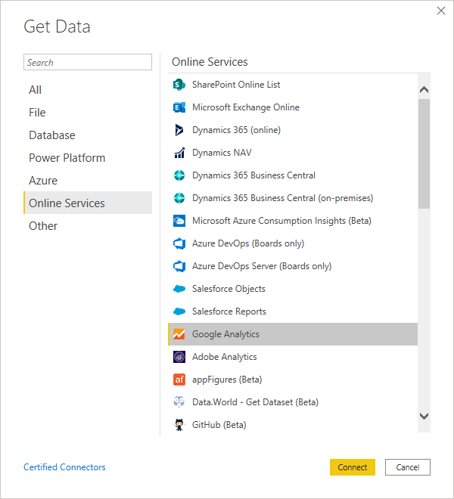
2. If this is the first time you're getting data through the Google Analytics connector, a third-party notice is displayed. Select Don't warn me again with this connector if you don't want this message to be displayed again. Then select Continue.
3. To connect to Google Analytics data through the legacy "Universal Analytics" API, select Implementation 1.0. To connect to Google Analytics data through the new Google Analytics Data API with support for Google Analytics 4, select Implementation 2.0 (Beta).
4. To sign in to your Google Analytics account, select Sign in.  
   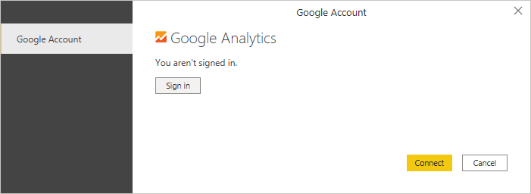
5. In the Sign in with Google window that appears, provide your credentials to sign in to your Google Analytics account. You can either supply an email address or phone number. Then select Next.  
   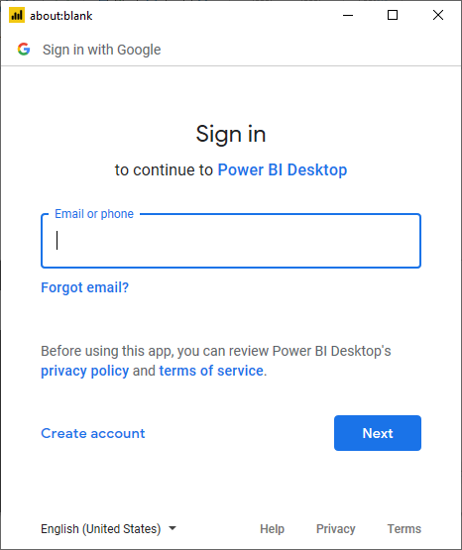
6. Enter your Google Analytics password and select Next.  
   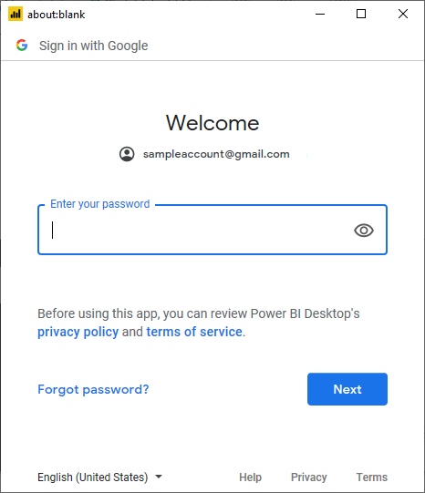
7. When asked if you want Power BI Desktop to access your Google account, select Allow.  
   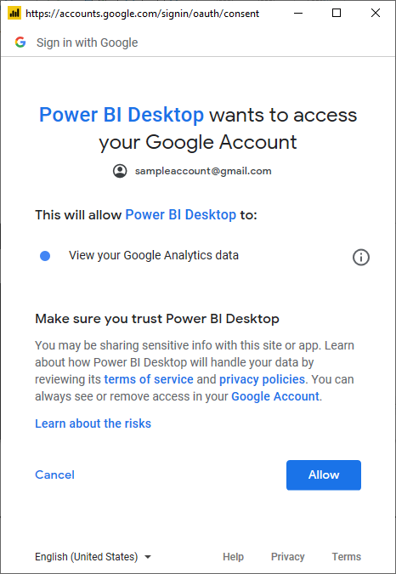
8. Once you've successfully signed in, select Connect.  
   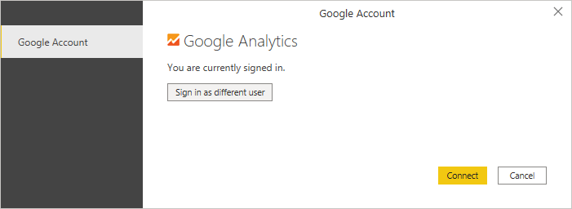

Once the connection is established, you’ll see a list of the accounts you have access to. Drill through the account, properties, and views to see a selection of values, categorized in display folders.

You can Load the selected table, which brings the entire table into Power BI Desktop, or you can select Transform Data to edit the query, which opens Power Query Editor. You can then filter and refine the set of data you want to use, and then load that refined set of data into Power BI Desktop.

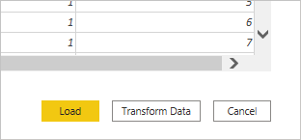

## **Connect to Google Analytics data from Power Query Online**

To connect to Google Analytics data:

1. Select Google Analytics from the Power Query - Choose data source page.
2. From the connection page, enter a connection name and choose an on-premises data gateway if necessary.  
   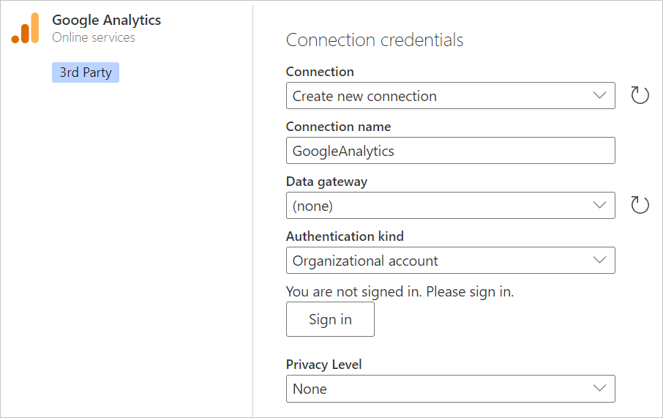
3. Select Sign in to sign in to your Google account.
4. In the Sign in with Google window that appears, provide your credentials to sign in to your Google Analytics account. You can either supply an email address or phone number. Then select Next.  
    Note  
   Currently, the Google Analytics sign-in dialog boxes indicate that you are signing in to Power Query Desktop. This wording will be changed in the future.  
   
5. Enter your Google Analytics password and select Next.  
   
6. When asked if you want Power BI Desktop to access your Google account, select Allow.  
   
7. Once you've successfully signed in, select Next.  
   Once the connection is established, you’ll see a list of the accounts you have access to. Drill through the account, properties, and views to see a selection of values, categorized in display folders.
8. Select Transform data to edit the query in Power Query Editor. You can then filter and refine the set of data you want to use, and then load that refined set of data into Power Apps.
9. How to import Local files in Power BI? Mention the Steps.

Answer: Import Analytics data manually through Power BI, follow these instructions.

1. In Power BI, click **Get Data** in the lower left screen.
2. Under **Import or Connect to Data** > **Files**, click **Get**.  
   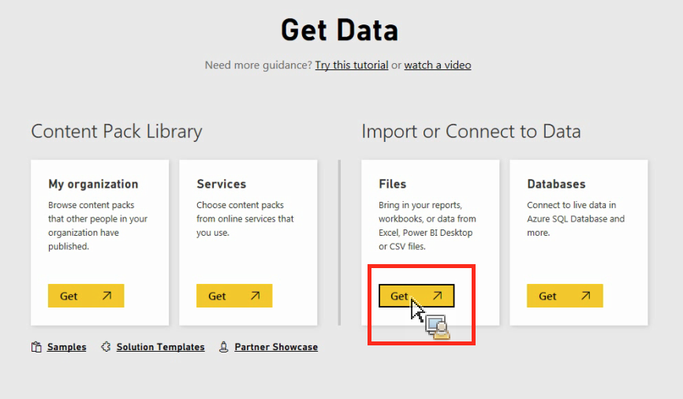
3. Click Local File.  
   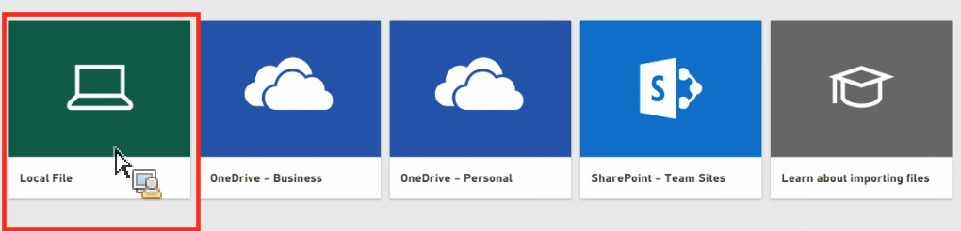
4. Choose which file to upload and click **Open**.
5. Click **Upload** under **Upload your Excel file to Power BI**.  
   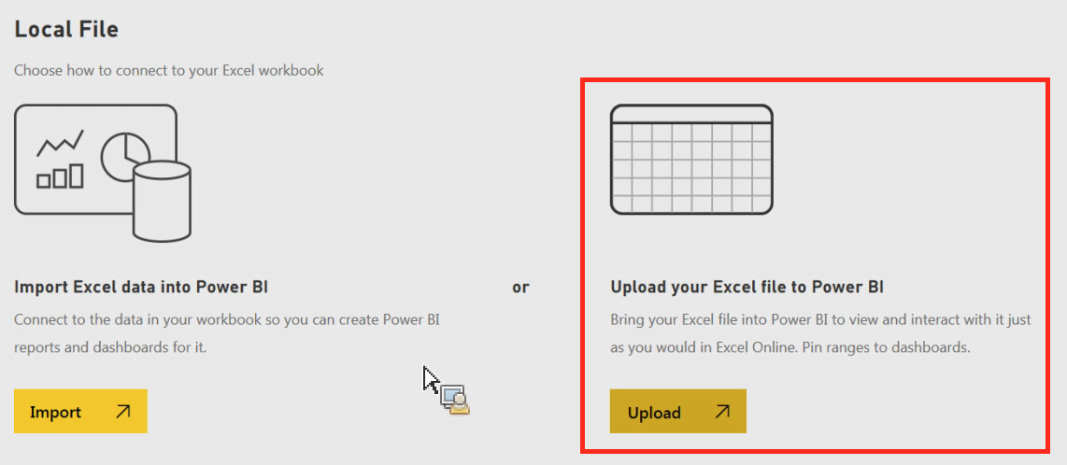
6. The message “Your file has been uploaded” should appear.
7. In Power BI visualization, what are Reading View and Editing view?

Answer: The Power BI service has two different modes for interacting with reports: Reading view for report *business users* and Editing view for report owners and creators. You need a Power BI Pro or Premium Per User (PPU) license to share reports and to edit reports created by others.

**1. Reading View:**

Reading View is the mode in which you consume and interact with your published reports or shared dashboards. It's the mode you use to explore and analyze the data visualizations that you or others have created. In Reading View:

* You can view the visualizations, charts, tables, and other elements that make up the report.
* You can interact with the visuals by filtering, drilling down, and exploring the data.
* You can use interactive features like slicers, cross-filtering, and tooltips to gain insights from the data.
* You can't modify the layout, design, or content of the report while in Reading View. It's meant for viewing and analysis only.

**2. Editing View:**

Editing View is the mode in which you design, create, and modify your reports and visualizations. It's the mode you use when you're actively building or editing the content of a report. In Editing View:

* You can design and arrange visualizations on report pages.
* You can add new visualizations, change their properties, and format them.
* You can create new report pages and customize the navigation between them.
* You can define calculated columns, measures, and other DAX calculations.
* You can set up data transformations using Power Query.
* You can apply filters, define interactions, and configure the overall layout of the report.

**Switching Between Views:**

You can easily switch between Reading View and Editing View in Power BI:

* Reading View: When you open a published report or shared dashboard, you're automatically in Reading View. You can explore the visualizations and data without making changes to the report's content.
* Editing View: To edit a report, you need to open it in Power BI Desktop or the Power BI Service. In Power BI Desktop, you can switch between Reading and Editing Views by clicking the "Edit" button. In the Power BI Service, you can open a report for editing by clicking the "Edit Report" button when viewing a report.

Both Reading View and Editing View are important for different stages of your reporting and analysis process. Reading View enables data consumption and exploration, while Editing View empowers you to create and refine your reports to effectively communicate insights.